

Extended techniques on the saxophone;
how to deal with them and the science behind

Jurij Bregar
Koninklijk Conservatorium Brussel
Erasmushogeschool Brussel

A thesis submitted for the degree of
Master in Saxophone
Brussels, May 2024

Acknowledgment

I would like to thank my professor Simon Diricq for the years I spent under his guidance. Helping me discover the possibilities of the saxophone and being patient and understandable during our time together.
A big thank you also to my supervisor Kurt Bertels who helped me to write this master thesis. All your advice and kindness are really appreciated.
A special Thank you goes to my parents Marta and Zvonko and my siblings Anja, Petra and Ivan Vid. Without your support I would have never been able to experience what I have. The time spent in Brussels will stay with me for the rest of my life. Thank you for making it possible.

Table of Contents
Chapter One: Introduction 1
Research Question and motivation 1
State of the Art 2
Methodology 4
Step 1: Gathering sources 4
Step 2: Interview, survey 4
Step 3: Personal artistic experiments 5
Chapter two: Explanation of Extended Techniques 7
Extended techniques in L’air d’ailleurs - Bicinium 7
Colour / timbre trills or bisbigliando 8
Various effects 9
Extended techniques in Saxophonequartett 11
Quarter tones, Sixth tones and Twelfth tones 11
Harmonic Multiphones / Multiphones 14
Extended techniques in babioles 16
Slap 16
Subtone / Niente 18
Flutter tonguing 19
Extended techniques in L’éveil de la toupie 19
Altissimo register 20
Double tonguing 20
Glissando 21
Chapter three: approaches in working on extended techniques 23
Approaches on extended techniques in L’air d’ailleurs - Bicinium 23
Colour trills / bisbigliando 23
Various effects 25
Approaches on extended techniques in Saxophonequartett 29
Quarter tones, Sixth tones and Twelve tones 29
Harmonic Multiphones / Multiphones 30
Approaches on extended techniques in babioles 31
Slap 31
Subtone / Niente 33
Flutter tonguing 34
Approaches on extended techniques in L’éveil de la Toupie 35
Altissimo register 35
Double tonguing 36
Glissando 37
Bibliography 39

Chapter One: Introduction

Research Question and motivation
In my master's thesis I will talk about the extended techniques of the saxophone and my experience with them in the pieces I play for my master recital. I chose this topic because, in the past few years, I have started to play pieces that require the performer to play an instrument in a special way. It often requires a lot of effort before a performer can comfortably perform a section of extended techniques. This leads me to the following main research question:
How can I as a saxophonist practice extended techniques?
This question can be further subdivided in two sub questions:
- Which extended techniques do I have to use in the pieces I play, what are they in the first place and how do you play them?
- What are some of the approaches in working on extended techniques and how do they compare to mine?
The answer to these questions would not only help other inspiring musicians but would also be a great way to see how I deal with those problems myself. Where am I losing time and what could I have done to master a certain technique faster and better. To understand myself better and to try to explain things I take for granted.
For my master recital I have selected compositions which can help me find an answer to my artistic research questions. This selection will be the following:
- The piece that I would play first on my recital would be by Fabien Levy and it is called L'air d'ailleurs – Bicinium. It is a solo piece with electronics where you must not only play your saxophone but also oversee a reverb pedal and must move closer and further away from the microphone. I think it would serve as a great example of extended techniques as it is required to play double tonguing, slaps, glissandos, quartertones, and many more on the saxophone.
- The second piece that I would play is a piece by Georg Friedrich Haas called Saxophonquartett. It is a piece for a saxophone quartet, and it shows extended techniques like quartertones, sixth tones, twelve tones and harmonic multiphones. It is not so often that we see the use of these kind of extended techniques. Moreover, it would be great to show my chamber music skills in a piece like this and prove that I can play also tenor saxophone.
- The third piece in my master recital would be a solo piece by Marc Monnet called Babioles. It is a twelve-minute piece divided into six smaller movements each one showing one of the characteristics of a circus man. It is quite a taxing piece to perform due to its very clear writings that demand the performer to be precise in his playing, especially in the dynamics. Besides that, it also includes extended techniques like slap, glissando, and quartertones.
- The last piece would serve as a kind of mix of all the extended techniques. It is written for alto saxophone and piano and it is called L'eveil de la Toupie by Vincent David. It includes almost all the extended techniques mentioned in the pieces before with an emphasis on the altissimo register and would therefore be great to conclude my master exam.

State of the Art
To formulate an answer to my research question I have gather various kind of sources such as books, articles and recordings. Firstly, I found a doctoral essay from Matthew Jeffery Taylor [2012] on teaching extended techniques on the saxophone. It offers a great understanding of not only learning extended techniques but also trying to teach them to other people and the best ways to do that. Another doctoral essay as an example could be from Iain Harrison [2012]. This source is full of useful information about extended techniques and their use in actual concrete pieces of the saxophone repertoire. However, my research will focus on different pieces, so it would be interesting to see the same extended techniques used in another way. Besides that, I will try to show you my side of the extended techniques and my way of working on them.
Various books on extended techniques could help me answer the question. One of them is from a legendary saxophonist Jean-Marie Londex [1989] and it is called Hello Mr. Sax ou parametres du saxophone. In it, he talks about the parameters of saxophone and its possible uses in the saxophone repertoire. Another book that is very well-known in the saxophone community is by Daniel Kienzy [2003] called Les Sons Multiples aux Saxophones. It offers almost all the saxophone multiphones on all four saxophones and is a great resource for studying them. Another book worth checking out would is by Larry Teal [1963] called The Art of Saxophone Playing. It was revolutionary for its time placing a big emphasis on the embouchure (since it was still heavily influenced by the clarinet) and developing the subtone technique. The book is in many ways regarded as the start of the American school of saxophone playing. Like the book of Lary Teal is a book by John Harle [2017] called The Saxophone. It offers an in-depth reference on playing the saxophone in this modern era. It explores various techniques with illuminating illustrations and new perspectives on embouchure, tone production, and other extended techniques. I must also mention a book written by a great saxophone teacher in Lyon, Jean-Denis Michat [2010], called Contemporary Saxophone. A great book about not only extended techniques but also posture, tone quality, timbre, performance, and all sorts of various things.
Let us not forget about several videos that would help us in our quest for extended techniques on the saxophone. One great series of videos about the extended techniques was made by Joshua Hyde [2020]. The series is called "Composer Resources" and consists of twenty-one videos where he explains all the possible effects on the saxophone. It is not only a great resource for composers who want to get to know the saxophone better but also for saxophone players who would like to understand the effects better. Another great video series is by Grace Kelly and Leo P, also known as "2SAXY" [2024] called "Saxophone & Performance Masterclass" where they talk about improvisation, altissimo register, bending the tone, vibrato, and many more extended techniques. This video series reminds us that one can use extended techniques also in jazz improvisation. One of the many video series that I found interesting is by Sean Hurlburt [2020] and it is called "Saxophone Altissimo". It takes a deeper look into alto saxophone altissimo and the origin of the fingerings. Sean also has some other playlists on his channel that explore some of the other saxophone techniques.
One of the people who could help me immensely in my research is my teacher, Simon Diricq [2020]. His knowledge of extended techniques and general saxophone knowledge is very large. He is aware of unusual fingerings and methods that are not very well known. He could help me deepen my knowledge about the saxophone. Another person who would be able to offer a different perspective on extended techniques is Vincent David [2020]. As a professor of saxophone with more than twenty-five years of experience and as one of the innovators in contemporary saxophone am sure have a huge insight into the world of extended techniques.
My research contributes to the existing materials in a way, that would put them through a test. That way I can share my experience with them and write if I found them helpful or not. Try to find out a better way of practicing extended techniques or show a new, unconventional way of practicing them.

Methodology
The methodology of this research will consist of the following steps:

Step 1: Gathering sources
Firstly, I must gather all the crucial sources mentioned in State of the art. Sort out the ones that do not apply in my research and focus more on the ones that do. Try and read as many articles as possible, books, doctoral essays and video and audio recordings. Anything that might help me in my research.

Step 2: Interview, survey
Sources like an interview, survey or an experiment are a great way to gather unique material. They are great, because you can make the parameters as you see fit and does not require to adjust yourself for the data. In an interview I would be able to ask some very specific questions that would help me the most instead trying to get something for everybody. The same goes for the survey and the experiment. Just the possibility to have something tailored for your research is very attractive.

Step 3: Personal artistic experiments
In this step I would concentrate on keeping track of my personal development on the extended techniques. How it changed over time and how I did I discover new methods of practicing. Perhaps the best way for this could be to keep a logbook of my practice routine and write down what I wanted to learn and what I achieved in a practice session. What has changed from last time and how I evolved with the piece itself.

Chapter two: Explanation of Extended Techniques
In this chapter I would like to explain the main ideas of the extended techniques in each of the four pieces that I will play for my master examination. Since there are so many in each of the pieces, I will focus only on the ones that I think are special to the piece and are not seen very often elsewhere.

Extended techniques in L’air d’ailleurs - Bicinium
The following is a list of all the extended techniques we can find in this piece:
- Quartertones
- Key-striking with sound
- Slap
- Colour / timbre trills (Bisbigliando)
  - More covered, more muted
  - More open, brighter
  - Close to normal tone colour
- Crescendo with “reverse sound”
- Aeolian sound
- Subtone / Niente
- Moving closer and further away from the microphone
- Breathy sound
- Glissandos
- Flutter-tonguing
- Multiphones
- Double tonguing
- Altissimo register
There are various extended techniques that are quite special in this piece, and I think would be nice to explain them in more detail.

Colour / timbre trills or bisbigliando
Bisbigliando or timbre / colour trill originates from the harp where the player needs to quickly alternate between two strings tuned to the same pitch. On the saxophone you would need to use slightly different fingerings then traditional for the same pitch to achieve a new tone colour as close to the original pitch. Something that would sound as the note being played normally, but with a change in timbre. The specialty of this piece is that the composer writes what kind of bisbigliando he wants - a more open one, closed one or one that is as close to the original note as possible.
Here we have a legend that explains to the performer when to play which bisbigliando:
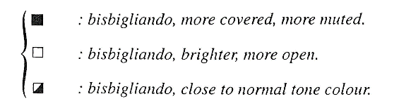
Here is an example of a bisbigliando trill in this piece. Notice how it is required that we play one Sib more open and the other one more closed that the normal Sib:
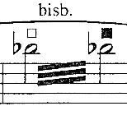
we can and here in this example clearly see all the bisbigliando possibilities:
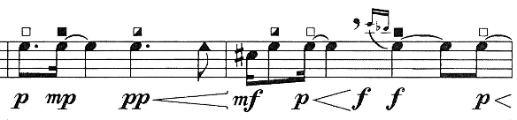

Various effects

Crescendo with reverse sound
This piece also uses several special effects. The first one I would like to highlight is the crescendo with “reverse sound”. In principle this sound effect could be explained by making a normal crescendo, but really pushing the sound at the end. To complete the crescendo as late as possible.
You can recognize it by two lines pointing upwards and downwards at the end of the crescendo:
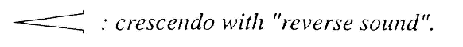
And here, we can see ”reverse sound” crescendo in action starting from mezzo-piano going to forte:
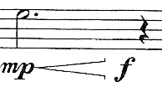

Reverb pedal and moving closer and further away from the microphone
Another special sound effect is made with the help of a microphone. By pressing the pedal and playing into the microphone, you can achieve the effect of reverb on the saxophone. That is certainly not something you see in every piece with electronics, especially with pieces that do not use electronics. Besides using the pedal, you must also move closer or further away from the microphone. This helps to amplify the reverb sound.
Here we can see both terms explained in the legend:

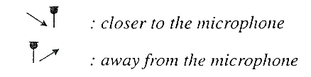
And in this example, we can see both techniques being used:
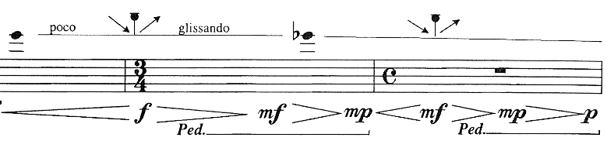

Aeolian sound / blowing into the instrument
One minor extended technique that is often overlooked by its simplicity is simply blowing into the instrument without making any pitch sounds. In the legend it is written as an aeolian sound, which comes from flute techniques. It is referring to the way you blow into the flute by changing the embouchure and airflow strength. In our score it simply says blow or “Souffle” on top of the note:
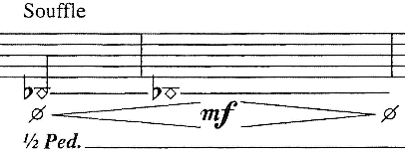

Key striking with sound
Finally, one technique that is also quite special in this piece is key striking with sound, double tonguing, flutter tonguing and blowing all together at the same time. Combining a lot of different extended techniques together leaves us with a cluster of sound that is perhaps unique to this piece:
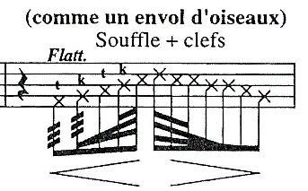

Extended techniques in Saxophonequartett
First let us start by listing all the extended techniques we can find in this piece:
- Quartertones
- Sixth tones
- Twelfth tones
- Harmonic multiphones
- Subtone
- Altissimo register
There are not as many extended techniques in this piece as in previous, but they are very special nevertheless and some of them are used very rarely. Let us take a closer look.

Quarter tones, Sixth tones and Twelfth tones
The idea of a quarter tone is simple. A pitch in between a semitone. Now the sixth tones are between the quarter tone and normal tone and the twelfth tone is between a sixth tone and a normal tone. That would lead us to the conclusion that there are two extra steps in between normal pitch and a quarter tone. That means that there are twelve steps just between one whole tone!
Here are all the quarter tone possibilities: This one explains the quarter tones:
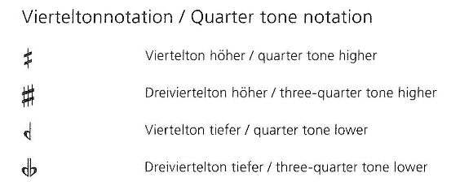
This one explains the sixth tones:
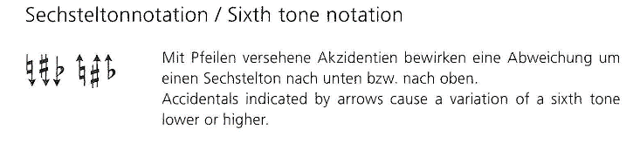
And this explains the twelve-tones:
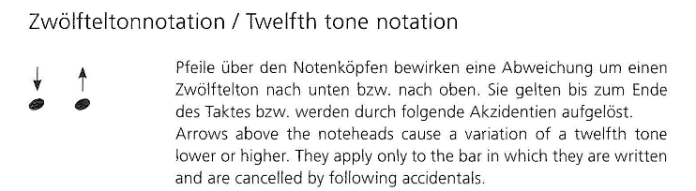
Finally, this graph explains us all the possible combinations between the quarter tones, sixth tones and twelfth tones:
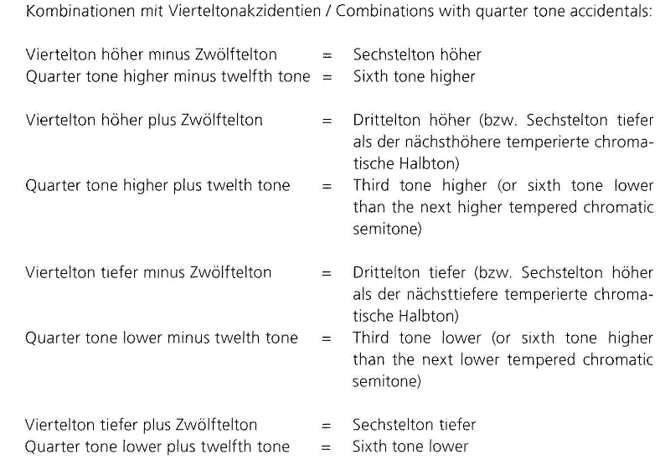
With all this material, the composer cleverly uses is to compose a piece full of dissonance and tension. One example of the use of all the micro tones are in the beginning of the piece where he effectively writes out a glissando using previously mentioned techniques.
In this example we can see that we start on Si and are then taken through the twelve steps to Do#:
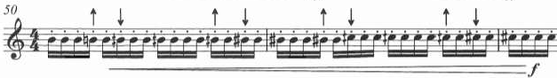
There are also other instances where the composer uses these techniques. One good example could be found here in this image (the score is written in C):
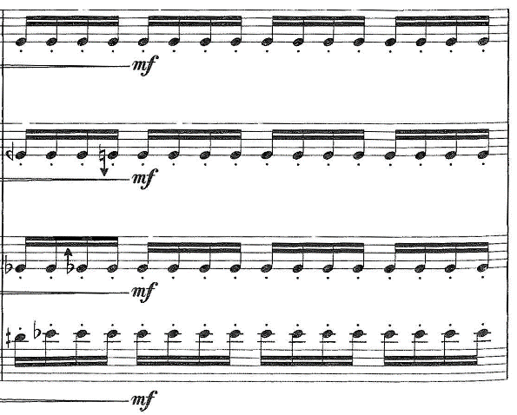
Notice how there is a cluster of notes in between MIb and Mi♮? The Baritone plays a MIb, the tenor plays Mib with a twelve tone higher, the alto plays Mi ♮ with a twelve tone lower and the soprano plays Mi ♮. This kind of chord creates a special kind of cluster that is quite uncommon.
There comes a point in the piece, where we can see two groups, divided on soprano and alto (group one) and tenor and baritone (group two) that start to play quartertones while being a quartertone apart and being an octave and fourth apart. This creates a very special line of melody and tension that I think is unique:
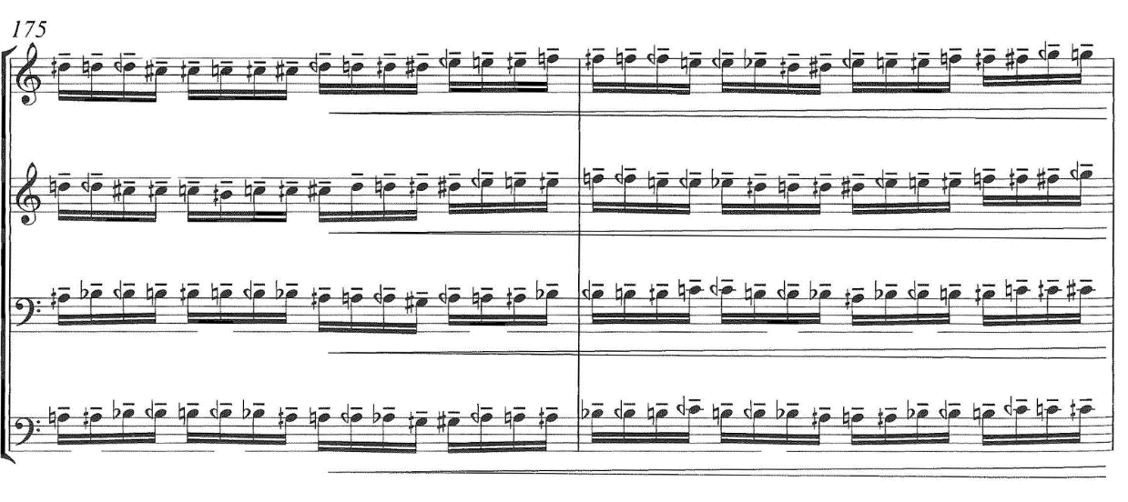

Harmonic Multiphones / Multiphones
When we are talking about multiphones we often think about an ugly sound that often includes quartertones and is difficult to produce on the saxophone. Usually with a not so comfortable fingering. However, this is not the case here. The composer cleverly takes advantage of the saxophones ability to play harmonics. In this case not just one but multiple at the same time, to create this colour template of the saxophone. It is also very cleverly used as a kind of bass where the other three voices support it.
Here is an example of how the harmonic multiphone looks like in the first place:
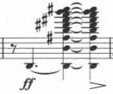
And in this example, we can see how the composer makes use of this harmonic multiphone by putting notes from the multiphone in other voices so that they become more apparent:
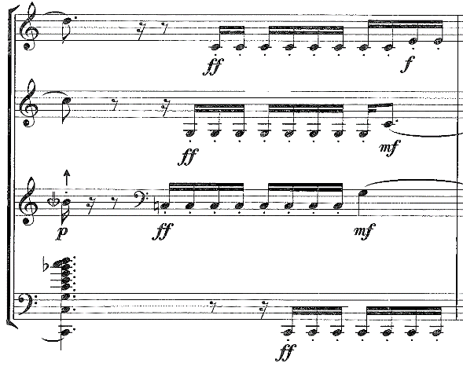
Of course, this kind of harmonic multiphones is not very common. Usually, multiphones come with their own set of fingerings. Some are easier to play than others. In most cases the multiphone is based on a fundamental pitch in the multiphone on which all the other harmonics are based on. Let us not forget that it is often required to change our embouchure position, our air direction and air strength to achieve the required multiphone.
As you can see in this example from Fabien Levy’s L’air d’ailleurs, there are fingerings written on top of the multiphones. In some cases, multiple fingerings are possible, we can also notice which will most likely be our fundamental note. On the third beat in the bar, we should hear a small portato glissando from FA-to-FA:
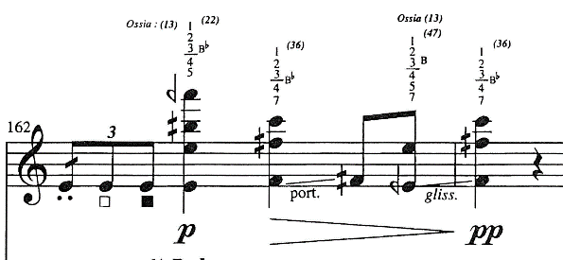
Quite often we must start with a normal note which then morphs into a multiphone. This is exactly what is happening in this example. The REb becomes the fundamental of the multiphone. In these cases, it is useful to make some of the fingering already on the note before the multiphone so that the transition is as smooth as possible and we can avoid the noise the change of the keys makes, especially here where we have written a pianissimo:
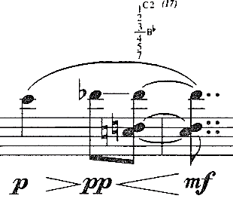

Extended techniques in babioles
Like before, let us start by listing all the extended techniques found in this piece:
- Slap
- Quarter tones
- Subtone / Niente
- Glissandos
- Flutter tonguing
- Air sound
- Circular breathing
In the next chapters I would like to take a closer look at the extended techniques that are present in this piece.

Slap
This extended technique is quite common in contemporary pieces. Perhaps because of its sound colour and many possible uses. In principle it should make a slap kind of sound, similar like on the bass guitar or other wind instruments like oboe or clarinet. For the musician to perform slap he or she should create suction on the reed so that it is pulled away from the mouthpiece and then when the tension breaks, the reed “slaps” back against the mouthpiece. That will create a kind of sound that is like a very violent attack but drier and with a different sound colour.
In principle we know many ways to perform slap but the main two in my opinion are open and pitched. The difference between the two is that in an open slap, we focus solely on the suction and release of the tension of the reed on to the mouthpiece. We are interested more in the percussive kind of sound. In a pitched slap, we put more emphasis on the pitch. For us to achieve that, we need to keep our embouchure in place, keep our mouth shut and add a bit of air while we release the tension of the suction on to the reed. Both have their advantages and can be used in all sorts of ways.
Not to forget that there is also dry slap, which is almost the same as the pitched slap, but the pitch is less obvious. Another technique of slap is a reverse slap, where we put the air before we create the suction and release of the tension. This creates the opposite effect as in pitched slap. Quite often we also see quasi slap in our repertoire. It is basically a mix between a normal attack and a pitched slap. A performer may also start the note with a slap and then continue playing the note. Instead of articulation the beginning of the piece normally, he or she starts with a slap and hold the note through. In this piece however, we only use the pitched slap.
The composer uses two kinds of writings for slap. Here we can see that the head of the notes are normal but since we have slap written on top, we assume that we play slap on those notes written below for the duration of the arrow:
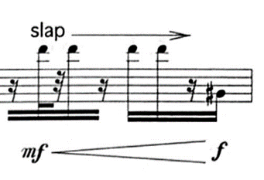
The other kind of writing for slap that the composer uses is the one where the heads of the notes are like the letter X with slap writing on top of it. Again, we assume to play slaps for the duration of the arrow and the X shaped note heads:
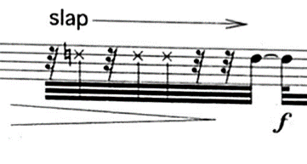

Subtone / Niente
Subtone is predominately used in the low register of the saxophone due to being less effective once we start using the octave key. Its origins go back to the early jazz era of Ben Webster and his use of a very fluffy kind of subtone. While it is still used to this day, the subtone has also changed over the years, where it is now used in a somewhat different way. The idea is to get rid of all the high partials in the sound. Like a filter that would allow just the low-end parts of the sound instead of the rich and full sound that we normally play with. It allows the performer to play soft dynamics in the low register with a clean sound.
With a good enough control, a performer may also be able to play niente. A technique where the sound gradually disappears into nothing or where it starts from nothing and becomes louder step by step.
There are several places where we could use the subtone in this piece.
First example could be found in the opening two bars of the fifth movement, where we start from pp on Do# and do a crescendo to ff. I think the optimal would be to start with a subtone and then gradually abandon it with the crescendo to achieve the ff. I would also play the Do# in the second bar in subtone:
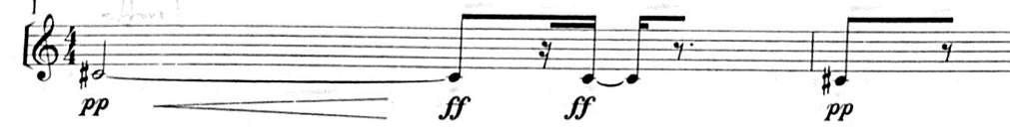
And here in this example we notice that we must go to nothing at the end of the bar. I would start the bar playing in mezzo-forte and then gradually add the subtone where I completely disappear at the end:
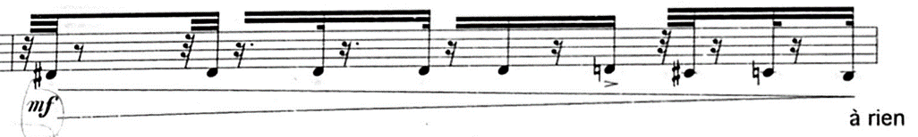

Flutter tonguing
Before moving on to the next piece I would just quickly like to mention one other extended technique and that is flutter tonguing. It is a technique where the performer flutters their tongue to create this Frrrrr kind of sound. It can also be produced by using your throat. It is present a number of times throughout the piece.
Here is an example of the flutter tonguing in the piece:
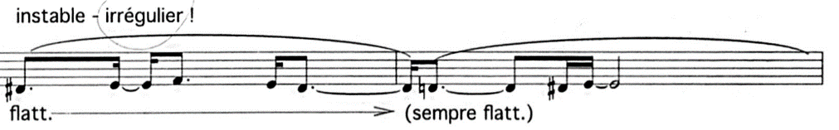

Extended techniques in L’éveil de la toupie
This piece includes the following extended techniques:
- Colour trills (bisbigliando)
- Quartertone trill
- Flatter tonguing
- Glissando
- Slap
- Subtone / Niente
- Double tonguing
- Altissimo register
- Air noise / breathy sound
- Multiphones
- Low La on the alto saxophone
- Use of side keys in trills or a passage
Like before, I would like to explain some of the extended techniques in more detail.

Altissimo register
Altissimo register is a register on the saxophone for which there are no specific keys, but rather a combination of them. That means that there are multiple fingerings for one note in the altissimo register. Some work better than others but there are of course endless possibilities. This piece uses quite a lot of altissimo register and in fact reaches quite high on the saxophone (Mib in the fourth octave). It is sometimes hard to find a good fingering for the altissimo register that does not disturb the equality of sound. Sometimes it is required to change the fingerings in the normal register so that the jump to the altissimo register is less evident.
One such example is found here where we must seamlessly switch between the normal register and altissimo register:
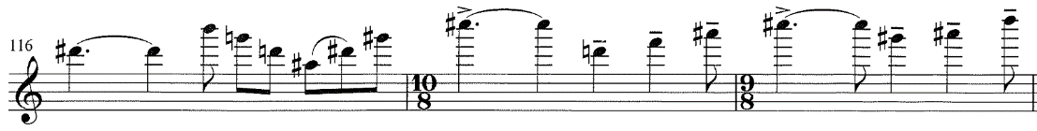

Double tonguing
This extended technique is helping the performer to play articulated fast passages that are too fast to play with normal tonguing. One can achieve double tonguing by articulating every other note with your tongue and doing all the rest with the throat. The idea is for the tongue to make a movement like saying the words TA–KA–TA–KA, with TA being articulated by the tongue and the KA by the throat. The vowels change depending on the context of the music. For example, in quiet dynamics the vowel may be DU-GU-DU-GU. The vowels also vary from instrument to instrument, since the angle of the mouthpiece is different on the clarinet or oboe for example. There is also a technique of triple tonguing or even quadruple tonguing. In these two techniques one plays two (or three for quadruple) times with normal a normal articulation and once with your throat. So, the tongue should be saying the vowels TA-TA-(TA)-KA. In this piece however, only double tonguing is needed.
Here is an example of a place where I would use double tonguing:
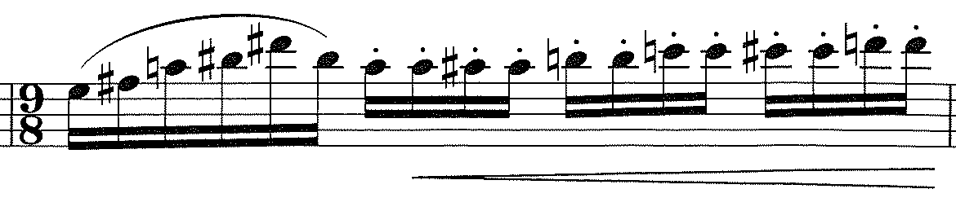
Another example of double tonguing:
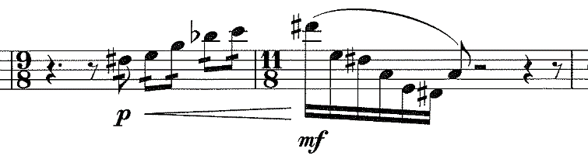

Glissando
This extended technique is probably the most fun to play out of all of them. It is quite simple to do on the saxophone and it does not take long to learn it. There are two or rather three ways one can perform a glissando. The first one is by slowly opening or closing your keys. This method works well if one must perform a glissando to or from a neighbouring note but usually not so well if there are a couple of notes in between. For that we usually use our throat. One must just be careful to be aware where he or she should finish the glissando and to play with the right intonation in the end. However, usually both techniques are applied at the same time. It helps the glissando to be as smooth as possible.
This glissando for example, I would perform with the throat because of the range of it. On top of that the tempo is much too quick to even try to do it with your keys:
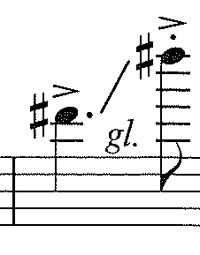
In this case however, I would simply slowly close the key with my finger since the glissando is only half note apart:
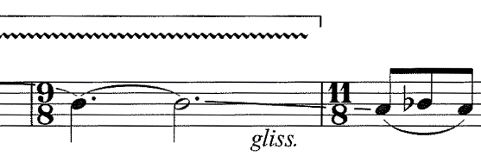
Finally, in this case I would use both techniques combined, since it would help the glissando to be as smooth as possible:
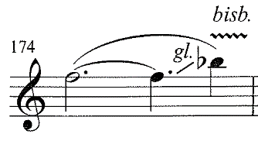

Chapter three: approaches in working on extended techniques
In this chapter I would like to write about different approaches on the extended techniques I exposed in the second chapter. To begin with, I would like to share some of my approaches in practicing these extended techniques and then explore other possible ways of practice.

Approaches on extended techniques in L’air d’ailleurs - Bicinium

Colour trills / bisbigliando
The first extended technique that we talk about in this piece is the colour trill or bisbigliando. Personally, I start with trying to find a good fingering. Searching and listening to make sure that the colour trill is as close to the actual note as possible. This process gets shorter with experience. I remember a few years ago searching for more than thirty minutes trying to find a good fingering. Adjusting my embouchure and my airflow to make a perfect bisbigliando. Now this process goes quite fast. Since a lot of them repeat in other pieces it is easy to remember which fingering to play.
In this case however, this process took a little more time, because I had to focus on the bisbigliando being more open, more closed or as close to the normal tone. In addition to this, I had to make sure that I could play all three with a fingering I could easily switch between. There were a lot of fingerings that would sound better, but I was forced to adapt them to be able to do a smoother transition between them.
One thing worth noting is that the colour trills vary from saxophone to saxophone. There is a place in the score, where the composer writes the fingerings on top of the trill. Unfortunately for me I found them not so accurate on my saxophone, so I was forced to adapt them a bit:
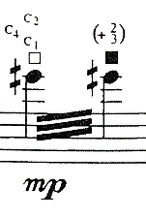
Fabien Levy. L’air d’ailleurs - Bicinium. Bar 34.
If we now, try and compare the colour trills in L’air d’ailleurs - Bicinium by Fabien Levy and Vincent David’s L’eveil de la Toupie the main difference is the speed of them and their use in the piece. There are only two instances where we trill with the bisbigliando in the piece by Fabien Levy, all the other uses for the bisbigliandos are tones on their own without any trill. As a performer I interpreted the intent of this colour trills not as to trill but to show different colours on the same not and not comparing it to the reference note. In Vincent David’s piece it is exactly the opposite. In my opinion he uses colour trills to make the note more special and to add a bit more sound to the piece. Quite often he pairs the colour trill with the flutter tonguing which make another special effect when combined.
So as an example, we can take a bar from Vincent David’s piece where we can see that the bisbigliando is meant as a trill, meant to add just a bit of new colour to the note:
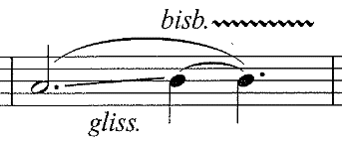
Vincent David. L’eveil de la Toupie. Bar 30
And here we can see the colour trill paired with the flutter tonguing:
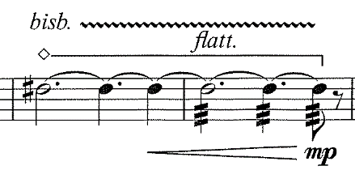
Vincent David. L’eveil de la Toupie. Bar 70 and 71.
In the piece by Fabien Levy it is less about the trill but trying to produce a new colour without making a trill. In a way it makes the switch between the notes more noticeable without the trill which is the effect I think the composer was searching for.
Here is an excellent example of the colour trills without the trills, where we are more interested in the colour not in the trill:
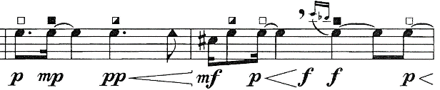
Fabien Levy. L’air d’ailleurs - Bicinium. Bars 39, 40.
In conclusion the main difference in colour trills in the pieces is that in L’eveil de la Toupie, we always trill as fast as possible and do not keep one other tone colour, while in L’air d’ailleurs - Bicinium, we are searching exactly for that, and only trill on two separate occasions in the piece.

Various effects

Crescendo with reverse sound
One of the many various effects found in the piece is crescendo with reverse sound. To successfully play it, one must have a tight embouchure, very precise control over airflow and flexible throat. The goal should be to hold your embouchure very tight for as long as possible in the crescendo and then at the very end of it loosen the embouchure. That will allow more air to flow through the instrument which in turn creates this effect of reverse crescendo. The danger here is that when we loosen up our embouchure, we stop blowing, but at that moment we should in fact blow more. The position of your throat also changes from closed to being more open, just like the embouchure. First to make the transition smoother and second, to keep the intonation of the note in tune.
In theory if there exists a crescendo with reverse sound, then surely a decrescendo with reverse sound must exist. It is not present in this piece however, to perform it, one should do the opposite of a crescendo with reverse sound. Now another question arises, what is the difference between a sforzato, forte piano and a decrescendo with reverse sound? In my opinion it all comes down to the attack of the note and the diminuendo afterwards. In sforzato for example, we use a harsh attack on a note, like it had an accent and a marcato written above it, after that we immediately go to piano, without bridging the loudness gap in-between. In forte-piano we use a softer attack, perhaps just an accent and then go to the piano dynamic, also not bridging the gap. In a decrescendo with reverse sound, we would also play the beginning quite loud, perhaps the most accurate articulation would be an accent with a tenuto. Then we would play a decrescendo from a mezzo-piano all the way down to piano or pianissimo. We would also make a decrescendo between the forte and mezzo-piano, but very fast.
Another approach to the crescendo with reverse sound could be to use just your air. To blow more in simple terms. A softer material would greatly help and improve this effect. It also depends on your saxophone and the mouthpiece you are using. For some people it may be easier to perform this effect than for others.

Reverb pedal and moving closer and further away from the microphone
A special extended technique that I also found in this piece is the use of the pedal and moving closer and further away from the microphone. I was hesitating to put these two methods as an extended techniques in the first place, since they are not really a part of saxophone and I felt like an extended technique should be a part of an instrument. The reason why I ultimately did include them was because I realized that they were a part of this piece and for me to perform them I need to do things with the saxophone that are not part of it. Something that requires a special or unusual approach to be able to perform it, even if it is not part of the instrument. One must nevertheless adapt his or her playing to this extended technique.
Regarding the reverb pedal, one must press it when it is written in the score. Perhaps the easiest allegory is the one of the reverb pedal we find for an electric guitar (ultimately it depends, which kind of pedal are you using). Similarly, we must press it only half-way sometimes, and other times we let it vibrate. One must get used to the feeling of pressing the pedal, since it is quite unusual at first.
The reverb is made with the help of a computer so we can choose how long the reverb will sound for, and this is perhaps also another special thing about this technique. Choosing the right kind of algorithm for the reverb and testing different kinds of reverb colours.
It also depends on the material we use. Which microphone do we pair together with the speakers, audio-interface, pedal, software and many more things. There are many different combinations and all of them have an impact on how the piece will sound.
And when it comes to moving closer and further away from the microphone, this movement is not really that complicated. In fact, many musicians do it naturally when they phrase so it did not pose any great difficulty for me personally. It is also quite logical in the way of writing, and it corresponds with the music perfectly. The only tricky thing maybe is to find a good position for the microphone, since it must be in a somewhat easy position for the performer to get to but not block the view or be of any disturbance.

Aeolian sound / breathing into the instrument
We can again ask ourselves if this is an extended technique in the first place? After all we need to blow into the saxophone to produce a sound. Is that not what we are supposed to do? And yes, I agree, this extended technique may be on the border with not being an extended technique at all, but there are reasons to believe why it could be considered one.
Personally, I think that one of the main reasons I treat is as an extended technique is that you must change many things to get the right kind of blowing effect. It looks quite straightforward, but to play it with the intensity and right kind of sound one would have to adapt his or her embouchure, way of blowing and choose a vowel or consonant on which they will base their blowing on. Different vowels and / or consonants produce different kind of blowing sounds. One could also change the vowels mid crescendo to make the crescendo louder or quieter.
For example, one could start the crescendo with the word “su” and then change mid crescendo to “si”. This would amplify the crescendo with a smooth transition between. Couple that with a reverb pedal and you have a wind-like effect.
In conclusion there are several things that one must do to produce a nice and even blowing effect. Many things need to be in place for it to sound as it is meant to. As easy as it seems it is perhaps not so straightforward. To be fair, it is not so difficult to master this technique, and it is quite easy to replicate after.

Key striking with sound
What makes this extended technique special is that it is in fact a mix of various extended techniques sounding together. It is quite complicated to play all the different effects on their own, but combining so many of them together into one big extended technique is quite challenging for the performer. It is difficult to decide which extended technique one will prioritize. In the end, some of the effects are barely noticeable. One must choose which effects he or she wants to showcase more, and which would suit better in that moment of the piece.
To practice this effect, I would recommend firstly to practice each of the effects individually and then gradually add effects together until you can perform this extended technique as it is intended. Perhaps the biggest challenge is to combine the flutter tonguing together with the double tonguing. It takes some time to find a position for your throat that can produce both sounds at the same time. For me, blowing is linked with the key striking as I blow more the faster, I produce the key striking's. Then it is just a matter of putting those effects together and making them sound like a flight of a bird.

Approaches on extended techniques in Saxophonequartett

Quarter tones, Sixth tones and Twelve tones
Working on these extended techniques requires quite a long process to master. There are many ways you can work on these quarter, sixth and twelve tones but in my opinion, there are ultimately just two.
The first option is to find a book or a chart of all the quarter or micro tones and play the fingerings that are notated there. It is a great way to learn all the fingerings fast and does not require a lot of searching. However, it does come with a few setbacks. Since every saxophone is different and many people have different playing styles, the fingerings notated in the book may not be entirely accurate. Often you will have to adapt a fingering for your saxophone.
The second option is to search and discover the options on your saxophone by yourself. It requires much more time than the first option and it can be somewhat tiresome, but I think the result is worth the effort. What you get with this kind of work are unique fingerings that are custom designed for your saxophone and for you as a musician. One can adapt them to their liking and the way they connect with the other notes. One thing is to play the quarter, sixth and twelfth tones and another is to connect it with the other notes so that the transition is smooth. Quarter tone fingerings on their own are not so complicated to find, but to make them work with the other fingerings, that is more of a challenge. It also deepens your understanding of the saxophone and its mechanism. The way it works and what could be some non-conventional solutions.
Just to give an example, the quarter tone between sol and sol# is notorious for being very difficult to play, due to the way the saxophone is built. However, there is a way around that problem with a slight modification to the saxophone. The idea is to remove a small part of the cork that is located on the back side of the saxophone when you press the sixth key. That will cause one of the holes to not close completely, which will be open just enough to produce this quarter tone effect.
You also start to realize that a lot has to do also with the embouchure and where you are blowing into the mouthpiece. That is all part of searching and discovering the fingerings. This could also be another way of working with the quarter tones. The material one is using is in this case very important and can have a big impact on the sound later.

Harmonic Multiphones / Multiphones
The harmonic multiphone is quite an unusual extended technique since we normally use one harmonic note at a time. It is in fact quite challenging to produce multiple at a time. One must adapt their embouchure, throat position and blow much more than usual. The principle is very similar to the normal multiphone. There is a bass or root of the multiphone (usually that is one of the lowest notes on the saxophone, since it works best there) on which all the other tones are based on. The goal is to then play as many overtones at the same time as possible. What helps is to choose one note in the harmonic series that is easy to play together with the bass note and then try to get all the notes on the inside. One can go also in the other direction and go up from the bass and chosen tone.
Perhaps another way of working on the harmonic multiphone could be to practice each overtone individually with the bass note. It would make playing them together a lot easier since you would already have a feeling for the position of your throat, embouchure and where to blow in your mouthpiece.
The fingerings for this multiphone are also quite straightforward. If you are doing a harmonic multiphone on a low Bb, you must simply hold its fingering and do the rest with your throat and embouchure. That is an advantage because the fingerings are not very complicated but on the other hand one must adapt very much for it to work.
Usually, we have a special fingering when we are playing a multiphone. It often requires the performer to put their hand in an uncomfortable position but is therefore a bit easier to perform. It also does not require the performer to play nine tones at the same time as in the harmonic multiphone but often somewhere between two and five.
Every multiphone is different and is practiced in different ways. If one is playing just two notes as a multiphone, one must hear both at the same time. There really is no tone who is more important than the other. However, if one is playing three or more tones at the same time, then it would be appropriate to select a main note and a bass note. These two need to be present for the multiphone to sound good in the context of the piece. The goal becomes then to produce the rest of the notes in the multiphone, that are more difficult to play.
Like mentioned before, it helps to practice each note individually in the multiphone and then going from the main note to all the other notes. In doing so you not only get a feeling for where the embouchure and throat need to be, but also practice your flexibility and muscle memory, since it often requires fast changes to and from normal tone.
All in all, the multiphones are not the easiest extended technique. It requires a lot to effort for some multiphones to make them sound consistently good. It all comes down to the way one practices them, their flexibility and the material they are using. It is often easier to perform a multiphone with soft material, although it depends on the multiphone.

Approaches on extended techniques in babioles

Slap
This extended technique was for me the hardest to master. There are several things that can go wrong while you perform this effect. Either your reed is too hard, too wet, too dry, not responsive enough, you have too much saliva, slap comes out too loud or too soft, the list can go on. The point I am trying to make is that this technique requires almost perfect conditions to work. It is worth the effort once the slap sounds in its full glory. It is probably also one of the hardest techniques to learn. Of course, there are people who started to play slap naturally, but for those who were not so lucky, the journey was long and hard in comparison to the other extended techniques.
There exist multiple kinds of slap, but since we are using only pitched slap in this piece, I think it is best to solely focus on that. To produce this effect, one must create suction on the reed. When it is released, the reed violently hits the mouthpiece which in turn creates the effect. In the beginning it is quite difficult to create suction. I used to practice on a spoon or my tenor mouthpiece, since it has a bigger reed and therefore a bigger surface where I could create suction. The tricky part is once you have figured out how to do suction to blow some air while you do it. That will allow you to make a pitched slap. The surface of your tongue with which you create slap also varies on the kind of slap and the dynamic of it. For example, in softer dynamics I use less of my tongue, while in louder I use more. All in all, it took me from three to six months to figure out how to perform a pitched slap.
Slap is also heavily dependent on the material we use. Softer material generally makes it easier to produce a pitched slap however, some pieces require (or sound better) on a harder reed. Finding a reed with which you can comfortably slap and play with a good, strong sound is hard. There is also a chance that you accidentally break your reed because of using slap to much or too hard. Eventually you find a reed that is responsive enough but another thing to be aware of is your saliva. Since you are using a quite large portion of your tongue to produce slap, there is always a chance that your saliva gets in the way. Normally that is not so big of an issue however when the music is soft and fragile, the last thing we want to hear is the sound of the saliva in one’s mouthpiece.
As you can see, there must be quite a lot of things in perfect balance for the slap to sound. First, we need to have a feeling for where to put our tongue on the reed, when to blow the air out into the mouthpiece, the material we are using, and our mouth must have minimal saliva to avoid the disturbing sound of it. Those are all the things that we need to make sure when we are playing slap. If only one is not working properly, it can cause the slap not coming out right.
In babioles, one of the things I had to decide is, which kind of material will I use. Since pitched slap is used quite often and the dynamic changes are very extreme and frequent, I decided to use softer material. It allows me to be more flexible in my playing and to really play what is written. Perhaps the quality of sound is not the best, but in this piece, we are not really focused on that. It is more about the abrupt changes in character, very precise rhythm, extreme polar dynamics and use of extended techniques like pitched slap.
My approach on working with pitched slap in babioles was straightforward. The thing with slap is that it is hard to learn and control it, but once you do, it does not pose any great difficulty. So, my approach on working with slap was to just try and find a good and easy reed with which it is easy to produce slap and then practice with it. Perhaps the things that I had to pay attention to is that the dynamics are accurate, that the slap would sound in the high register (it comes out a bit harder there) and that I can perform it immediately before or after a normal note (since you need to prepare your tongue and embouchure). Other than that, I did not really pay a lot of attention to pitched slap. I got really used to doing it, to the point that I do not even need to think about it anymore.
In conclusion, the pitched slap relies heavily on the material you are using and is hard to learn, but once you know how to produce it, it becomes easier to play.

Subtone / Niente
I was hesitant to put these two as extended techniques as they can both be done in a normal way by simply tightening the embouchure to the point where your sound is very quiet, or it disappears. That is quite hard to do, and it requires a lot of practice and good, easy material. The reason I decided to include them is because I mainly use two other approaches to subtone and producing the niente sound effect. They both require the player to adapt their way of blowing, embouchure and tongue position among others.
In the first approach I simply put my tongue on the reed and lower your jaw. That limits the vibration of the reed which in turn allows me to play much softer than usual. The tongue acts as a kind of filter which allows only the low frequencies of the sound and blocks the high ones. That is why subtone is used predominately in the low register, since it loses its effect the higher it goes. In babioles, I use this effect quite often. It helps me to make a difference between the different types of soft dynamics.
The second approach can be used together with the first one or by itself. For it to work, you simply need to remove your upper teeth and again lower your jaw. You must keep your embouchure in place otherwise you can lose the grip on your mouthpiece and do not forget to blow. This technique can be coupled with the first approach. Combined they allow you to play even softer in the low register. Making a niente with the two approaches does not pose any problems.
The biggest difference between making subtone and a niente is that while you are making subtone, you keep the same position of your throat and embouchure, while in niente you slowly close the gap between the reed and the mouthpiece.
I use both techniques in babioles. They allow me to be precise with the dynamics and play with ease in the low register. One thing that makes it easier is of course softer material. You must be careful on your saliva though. Since the tongue is usually full of saliva, putting it on the reed will give you some sounds that are not so pleasant to listen to. This problem is quickly solvable by not eating anything sweet before you play and eat something like a banana which will reduce your saliva production in the mouth.

Flutter tonguing
Flutter tonguing can be done by mainly two approaches. The first one is by doing frrrr with your tongue. You must keep your embouchure and air flow the same way for it to work properly. Personally, I have never learned this technique as I found the second approach working better for me and I was never put in a position where doing this technique with the tongue was necessary or better.
I am always using my throat to produce the flutter tonguing effect. I am fortunate enough that this effect came naturally to me, and I never needed to put any effort into learning it. You simply gurgle with your throat or make a grrr kind of movement in your throat and that is everything you need to do. It sounds just as the flutter tonguing and is easier to produce (at least for me).
There are instances where it is difficult to maintain it. Mainly in the high register where the position of the throat is much more open than in the low register and therefore much harder to make the grrr motion.
In babioles it is a common technique and is used in all kinds of dynamics. While practicing I pay attention to the sound of the flutter tonguing because it is sometimes difficult to make it sound clear in comparison to all the other techniques especially in the softer dynamics.

Approaches on extended techniques in L’éveil de la Toupie

Altissimo register
The altissimo register serves as a kind of extension to the saxophone. It allows it to play at least an octave higher than usual. Since there are multiple fingerings for the same notes in the altissimo register, one can choose between the ones that are working best for them. Every saxophone and saxophonist is different and there are various approaches to the altissimo register.
The first step for playing altissimo register is to tighten the embouchure and open your throat. It took me some time to get used to the feeling in the mouth. I remember playing with less of my lower lip, because it made the altissimo register easier. The second step is finding good fingerings that will allow you to transition seamlessly from either normal register into the altissimo register or between notes in the altissimo register. There are whole charts dedicated to this problem. At the beginning it is very helpful. Some fingerings are passed down from teacher to student and there are no records of them in any of the books. Eventually you learn all the fingerings by heart and that is when you start to experiment and trying to find custom fingerings that respond well to you and your saxophone. Often the fingerings from the chart are bad with intonation or are good but just not compatible with the fingering before. When you have a sense of how the saxophone works and how you can manipulate the sound with your embouchure or other fingers, it becomes fun to search for a good fingering.
In L’eveil de la Toupie I was searching for easiness of the fingerings and a good, strong sound. Since the tempo in this piece is quite fast, I knew that I needed to find fingerings that would be easy to transition to. Then I started to try search for the fingerings that had the biggest and fullest sound.

Double tonguing
This extended technique is used when normal articulation becomes too difficult to produce. Instead of articulating every note in a passage, we articulate only every other note, the rest we articulate with our throat. There are some vowels with which it is easier to achieve this effect of double tonguing. I personally use TA KA TA KA vowels. TA is when I use my tongue and when I am using my throat, I use vowels KA. It also depends on what kind of passage it is. Sometimes I will change my vowels to DA GA DA GA for when I need to play a more tenuto passage.
Here in this piece, I am using a special approach. Here in this example, it can be hard to start with double tonguing immediately, so I have decided to play just the first two notes with normal tonguing and the rest with double tonguing. This is mainly because of two reasons, the first being that from the listeners point of view it is easier to understand the beginning of the passage and the second being that it is easier also for me the play, because it is quite hard to start double staccato in that register. So, the articulation would be TA TA KA TA KA TA in this passage
Vincent David. L’eveil de la Toupie. Bar 53, 54.
Another thing that is important while performing double tonguing is your embouchure and air speed. One must blow much more than usual and without a stable embouchure the double tonguing does not really come into effect.
As far as I know this is the only approach on double tonguing. It takes me quite a lot of time to play it with ease. Since I do not use it very often, I have to build some tolerance for it, and that can take somewhere between two weeks to a month of everyday practice of double tonguing. It is probably one of the techniques for which the only way to play it well is to practice it every day for a long period of time. I have not really found any better way than that.

Glissando
Glissando is an extended technique where we blur the notes in between two intervals. There are multiple approaches one can do. First one, and probably the most popular, is by doing glissando with the throat. This is quite easy to do in the high register but not in the low register. There we usually use the second approach, which is by slowly opening or closing the key. Most often we use a mix between the two approaches. This really allows us to make a smooth transition.
For the glissando to work properly, our throat and embouchure needs to be flexible, and our control of the fingers needs to be precise. In principle, one should make his or her bottom lip loose to make the note flat, and then come back into the desired pitch by correcting their lip back into place. The throat also plays an important role. We want to make a similar movement to a yawn, when we raise the roof of our mouth, and our throat is very much open. This allows us to easily manipulate the direction of the sound and makes the glissando come out naturally. Combining these two approaches makes this technique quite fun to play.
In L’eveil de la Toupie I use both approaches individually and together, depending on the situation in the piece. The choice of material is not that important with this technique. It really depends on the piece you are playing. Sometimes soft material is better and others hard. It is hard to say which is better for this technique.

Bibliography
ARTICLES:
Harrison, Iain. 2012. “An exploration into the uses of extended techniques in works for the saxophone, and how their application may be informed by a contextual understanding of the works themselves”
https://www.proquest.com/openview/5033f43d8d1bfdd565dcaed0a2ed05ab/1?pq-origsite=gscholar&cbl=18750
Taylor, Matthew Jeffery. 2012. “Teaching extended techniques on the saxophone: A comparison of methods”
https://eprints.hud.ac.uk/id/eprint/18047/1/iharrisonfinalthesis.pdf
BOOKS:
Kienzy, Daniel. 2003. “Les Sons Multiples aux Saxophones”
https://www.scribd.com/doc/225601518/Daniel-Kientzy-Les-Sons-Multiples-Al-Sax
Londex, Jean-Marie. 1989. “Hello Mr. Sax ou parametres du saxophone”
https://www.ateliercelia.fr/londeix-jean-marie-hello-mr-sax-ou-parametres-du-saxophone-p-3-52-5101/
Michat, Jean-Denis. 2010. “Un saxophone contemporain”
https://www.jdmichat.com/_files/ugd/75be97_aa0d44a7c3a1487787ebe84e3a357e7e.pdf
Harle, John. 2017. “The Saxophone”
https://www.johnharle.com/the-saxophone.htm
Teal, Larry. 1963. “The Art of Saxophone Playing”
https://www.scribd.com/document/227240724/larry-teal-the-art-of-saxophone-playing-pdf
VIDEO SERIES:
Hurlbrt, Sean. 2020. “Altissimo Saxophone”
https://www.youtube.com/playlist?list=PLiOq7Zb9XQ-46FK8eOX5FKiZJk--Y9uKW
Hyde, Joshua. 2020. “Composer Resources”
https://www.youtube.com/playlist?list=PL3RDBJurtd-wL-Z6GnDR0QcqCboPOHNwO
Kelly, Grace. P, Leo. 2SAXY. 2024 “Saxophone & Performance masterclass”
https://www.youtube.com/playlist?list=PLi5xJKFr5vagK8-cU5PBXNWXZhujsd5EZ
WEBSITE:
David, Vincent. 2020. “Website - Vincent David”
https://vincentdavid-sax.fr/en/
Diricq, Simon. 2020. “Website - Simon Diricq”
https://www.simondiricq.com/

